NPP Student Academic Success Plan
Date__________________ Semester___________________________
Name____________________________________________ Major_______________________________________________

Current Cumulative GPA:
Semester GPA Goal:
Academic Success Plan
My goal this semester is to achieve a semester GPA of at least_______________________

I understand that I must take the following actions this semester, which are essential for all students seeking academic success:
- Develop and keep a weekly study schedule (please fill out the provided schedule template, include internship and personal schedules).
- Submit all assignments on time. In case of emergency or illness, I will immediately notify my coordinator and instructors requesting more time and including a plan to submit any missed assignments.
- Meet weekly (at Study Hall) with my NPP Academic Coach for accountability with assignments, grades and study time.
- Reach out to my instructor immediately for assistance if a grade on any assignment or test is below a 2.0.
- Meet with my NPP coordinator throughout the semester and immediately for assistance if anything occurs that may affect my academic success.
- Utilize NU study resources (Brainfuse Writing Center, Brainfuse Tutoring, NU Library, Reference Librarians, writing videos, study skill videos, etc.) as assigned in Study Hall and as needed (suggested by coordinator) during the semester.
Academic Difficulty Factors and Action Plan to Deal with Them:
The top 3 factors contributing to my academic difficulty in the past were:
- __________________________________________________________________________________________
- __________________________________________________________________________________________
- __________________________________________________________________________________________

3 specific actions I will take this semester to address these factors are:
- ___________________________________________________________________________________________
- ___________________________________________________________________________________________
- ___________________________________________________________________________________________

Helpful NU Online Resources (See Academic Success page on Eagle here):
Smarthinking Online Writing Center Writing Guides & Videos
Instructor (reach out) Academic Success Tutorials NPP Coordinator/Academic Coach
Academic Advisor Study Skill Tutorials Library Resources
Reference Librarians Study Hall Other ________________________________

Additional notes (optional):

Student Signature _______________________________ Coordinator Initials___________

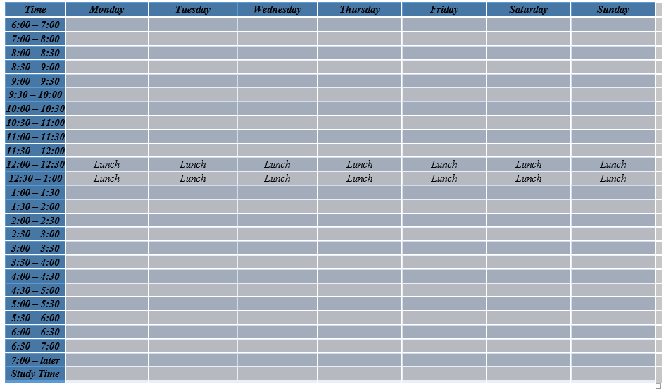
Weekly Schedule

